1. Phrasal verbs

|  |
| --- |
| **put off** | = | postpone | We **put off** the meeting until next week. |
| **handle** | = | deal with | Work is stressful, but Jim can **handle** it. |
| **get stuck in** | = | unable to leave | Lisa **got stuck in** Iowa because of snow. |
| **get on sb's nerves** | = | annoy sb | Do you **get on** Jim's **nerves** too? |
| **turn up at** | = | arrive, appear | Lisa **turned up** **at** Jim's house. |

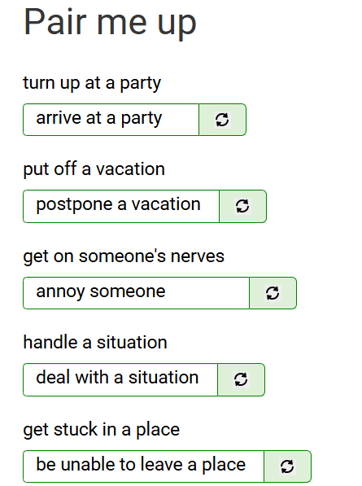

1. Phrasal verbs

|  |
| --- |
| put off | = | cause to dislike | That recipe **put** me **off** salmon forever. |
| put off | = | postpone | We **put off** the meeting until next week. |
| show off | = | attract attention to | He likes to **show off** his wealth. |
| get by | = | manage to live | Lots of people **get by** on less than $5 a day. |
| put up with | = | be willing to accept | How do you **put** **up** **with** him? |
| get along with | = | be friendly with | Do you **get along with** your boss? |
| put on | = | gain | I **put on** a lot of weight last year. |